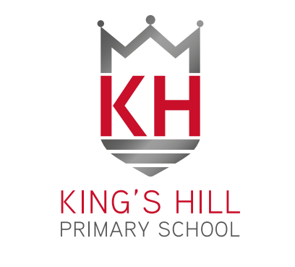**King’s Hill Primary School**

**Pupil Acceptable Use Agreement – September 2021**

**EYFS**

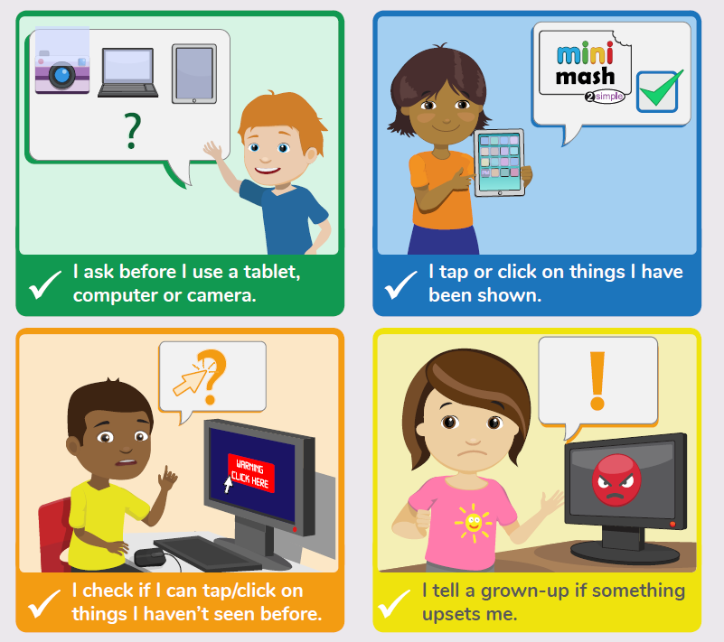

**Key Stage 1**

I will ask a teacher or suitable adult if I want to use the computer.

I will only use activities that a teacher or suitable adult has told or allowed me to use.

I will take care of the computer and other equipment.

I will ask for help from a teacher or suitable adult if I am not sure what to do or if I think I have done something wrong.

I will tell a teacher or suitable adult if I see something that upsets me on the screen.

I know that if I break the rules I might not be allowed to use a computer

**Key Stage 2**

I understand that the school will monitor my use of the computer/iPad.

I will keep my username and password safe and secure – I will not share it, nor will I try to use any other person’s username and password.

I will be aware of ‘stranger danger’ when I am communicating online.

I will not tell anyone my personal information about myself or others online.

I will immediately report any unpleasant or inappropriate material or messages or anything that makes me feel uncomfortable when I see it on-line.

I will be polite and responsible when I communicate with others, I will not use strong, aggressive or inappropriate language. I appreciate that others may have different opinions.

I will not take or distribute images of anyone without their permission.

I understand that the school has the right to take action against me if I am involved in incidents of inappropriate behaviour.

I have read and understand the above and agree to follow these guidelines when:

* I use the school systems and devices.
* I use my own equipment out of the school in a way that is related to me being a member of this school

**Name of Pupil: …………………………………………………………………………………………………………………….**

**Class: …………………………………………………………………………………………………………………………………..**

**Signed: ………………………………………………………………………………………………………………………………..**

**Date: …………………………………………………………………………………………………………………………………..**

**Parent / Carer Countersignature …………………………………………………………………………………………………**

NM – July 2021